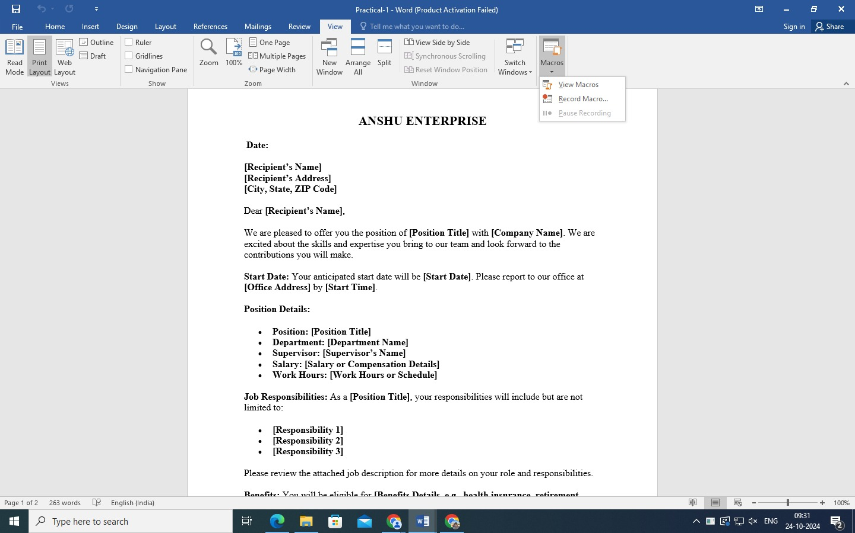**1) How do you create a macro in Microsoft Word to generate a customized appointment letter that includes placeholders for the recipient’s name, position, start date, and other details, and then execute the macro to produce a formatted letter?**

Use macro

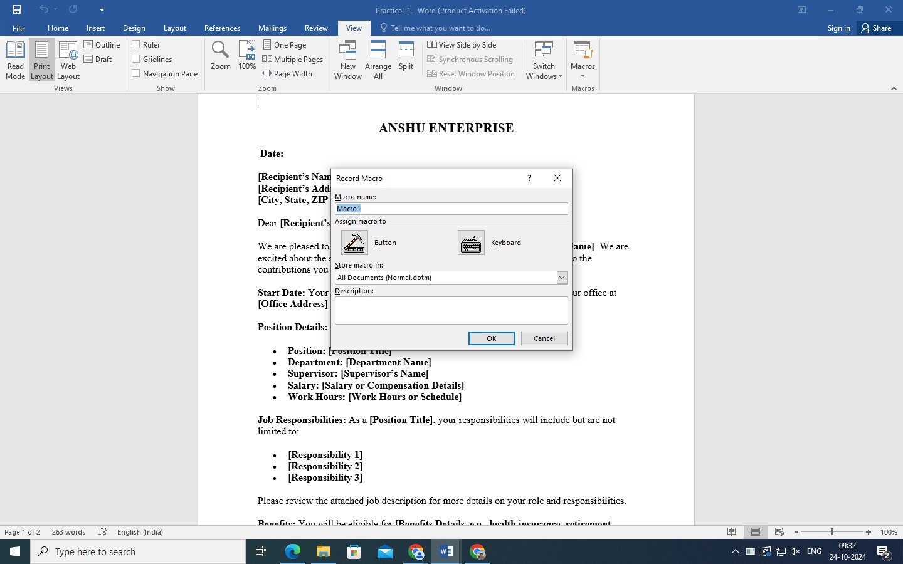

Enter the macro name

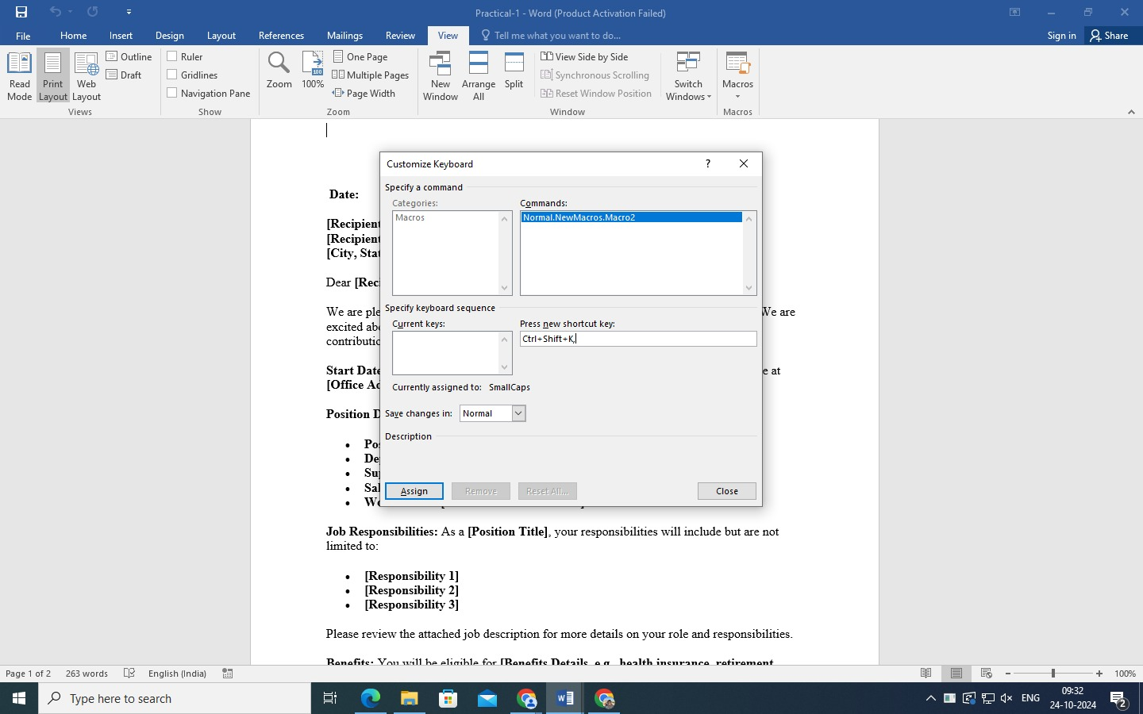

Enter the Shortcut key for macro

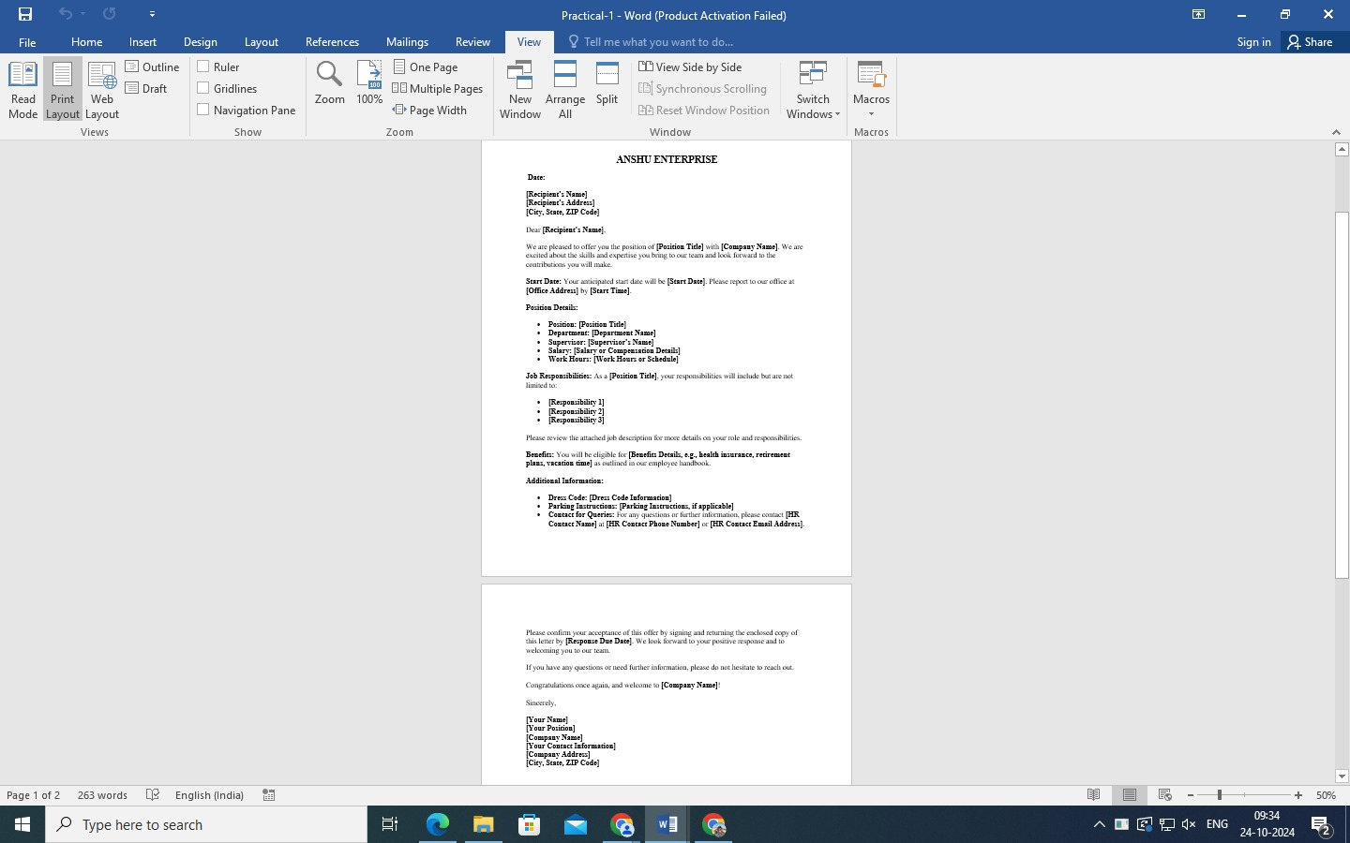

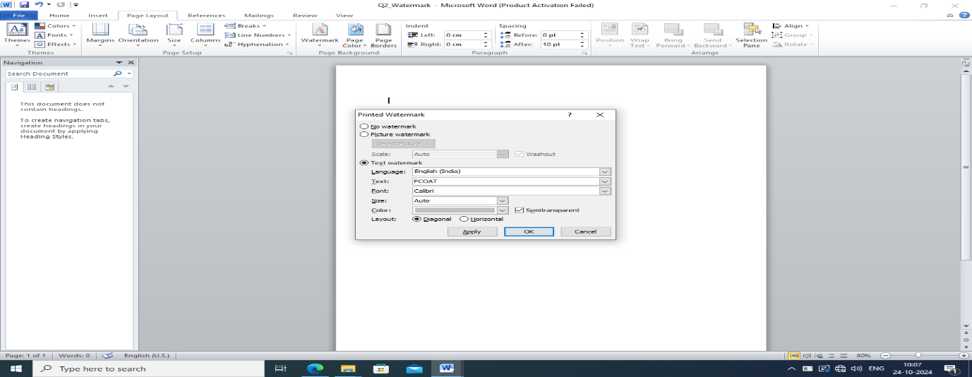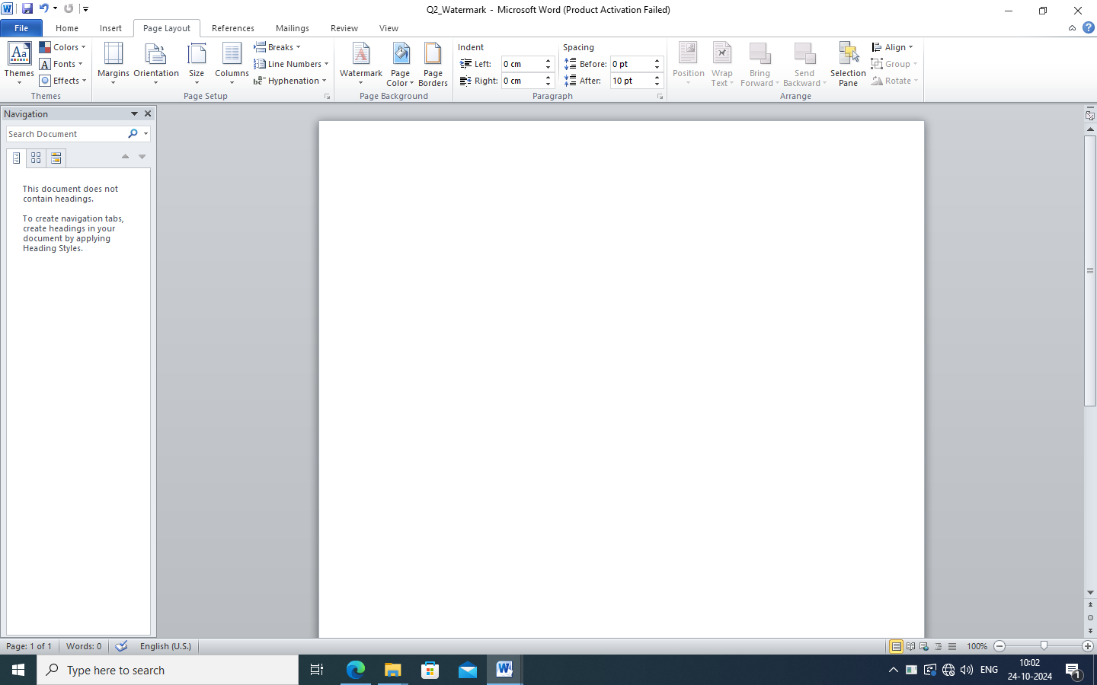**2) How can you can add custom watermarks to specific sections of a document, such as confidential or draft, based on the document’s status?**

Use Watermark

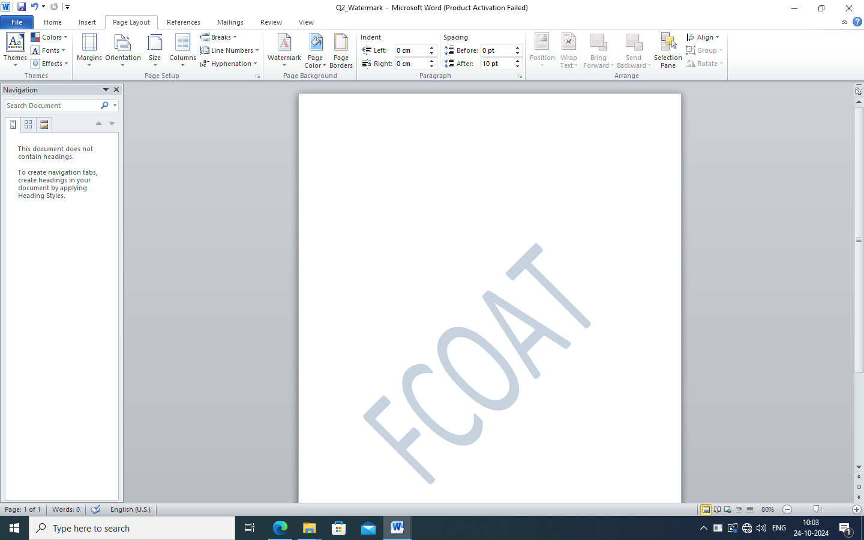

Use Custom Watermark

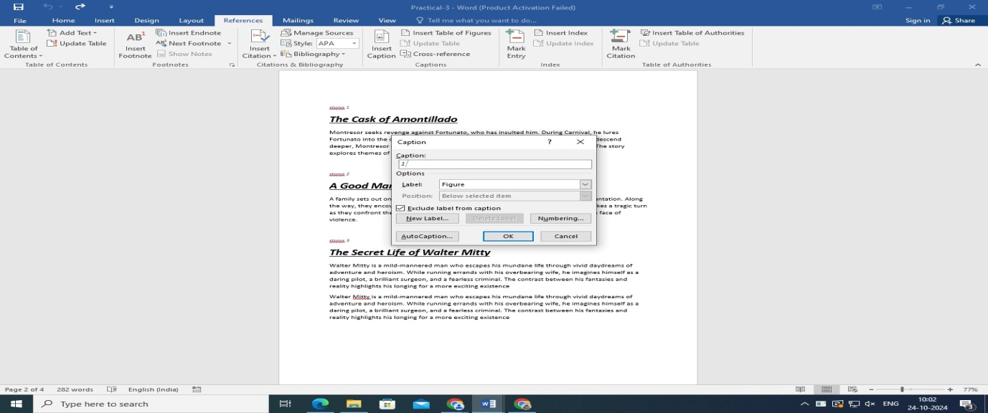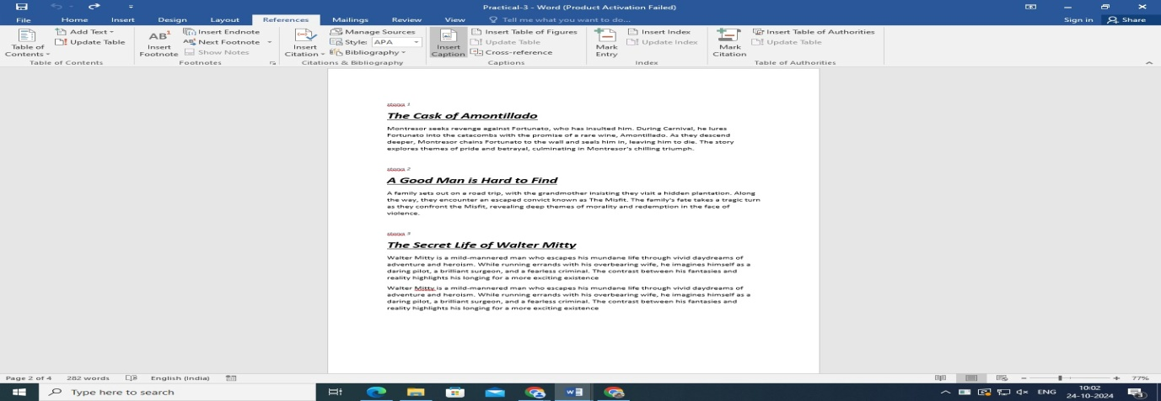**3) How can you set up a document to include a table of figures and a table of tables, each automatically updating as figures and tables are added or modified?**

Insert caption

Enter the caption

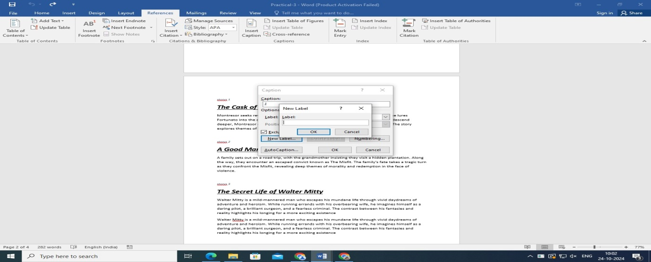

Enter label

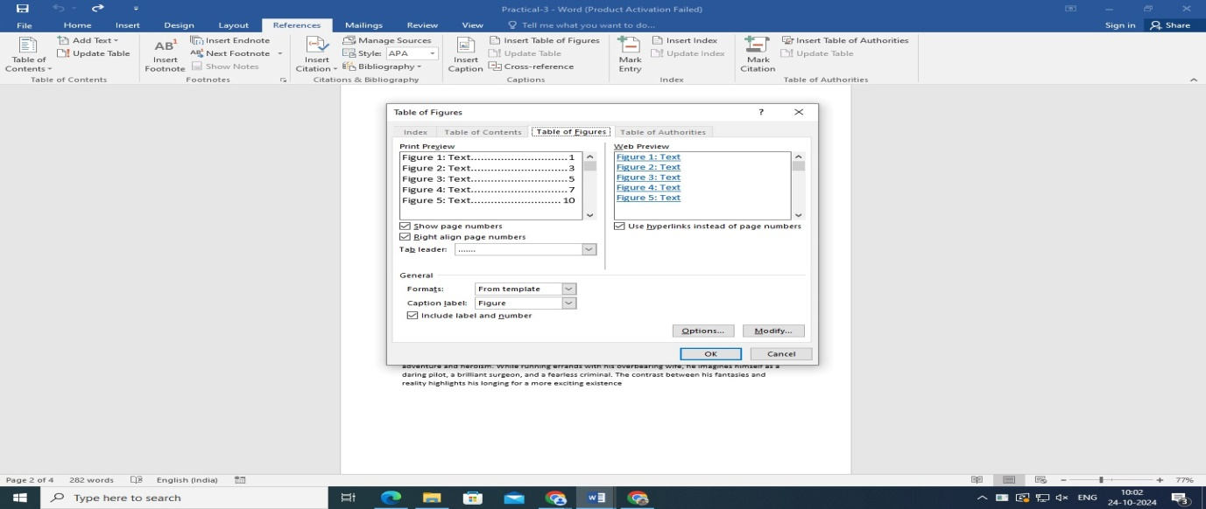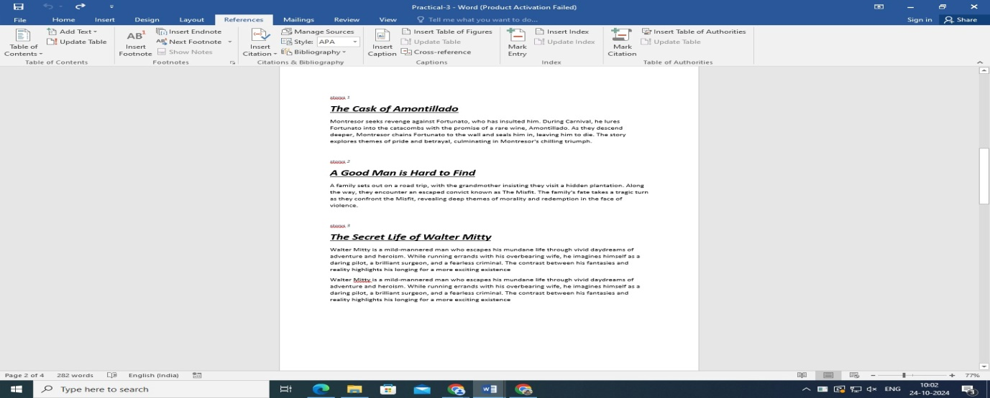

Choose the option for table of figures

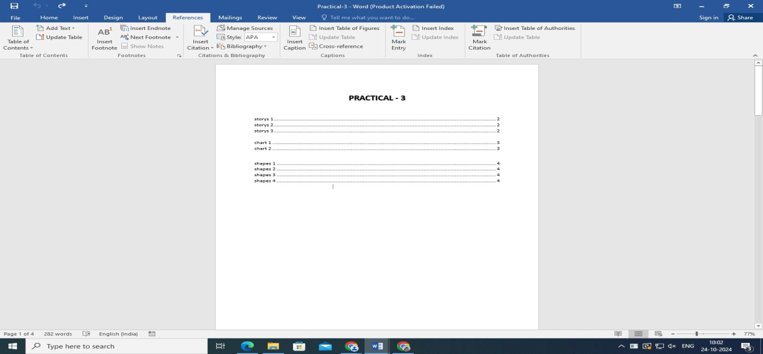

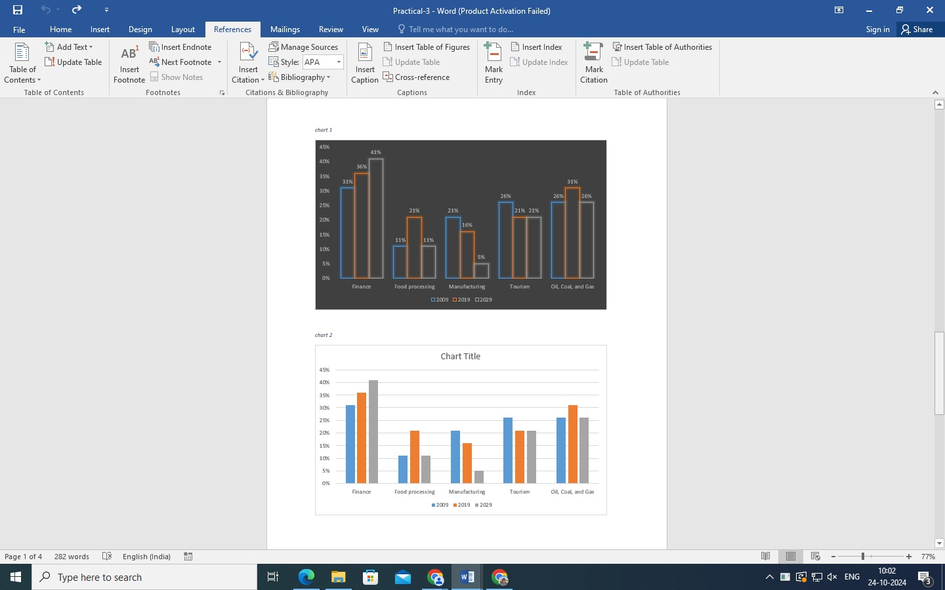

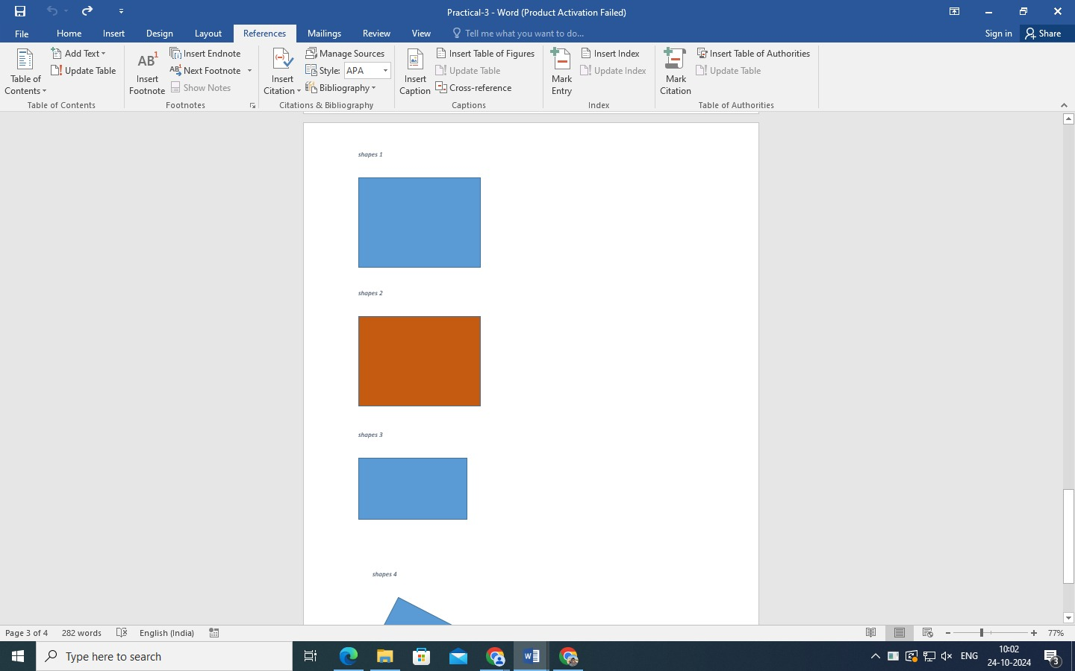

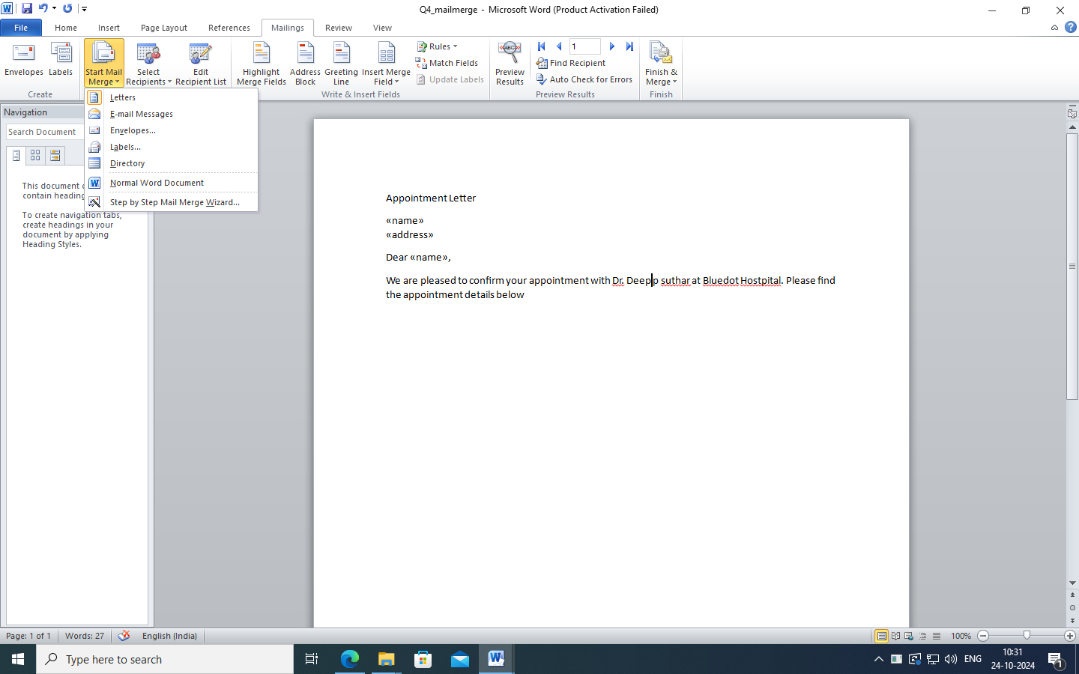**4) How do you perform a mail merge to generate personalized form letters, labels, or envelopes from a data source like an Excel spreadsheet?**

Use mail merge And Merge with Excel spreadsheet

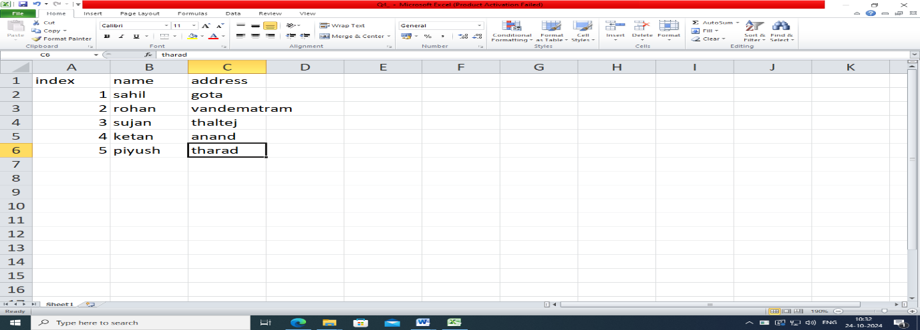

Merge with the Word file

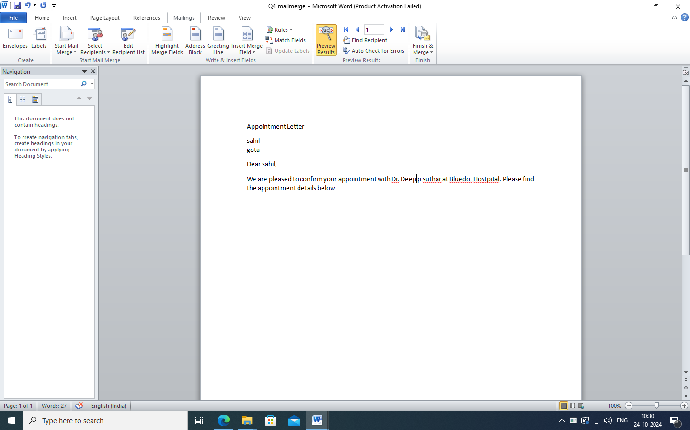

Use Preview Result

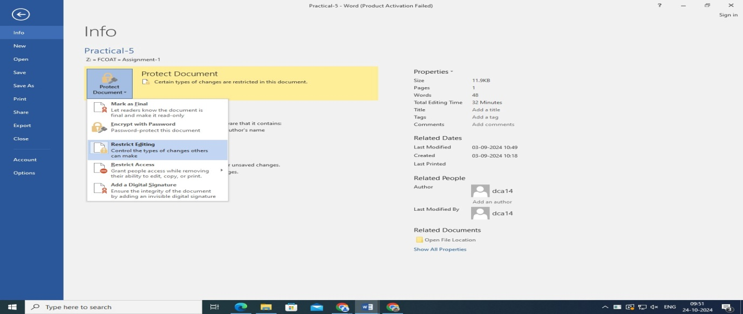**5) How can you protect a document from editing ?**

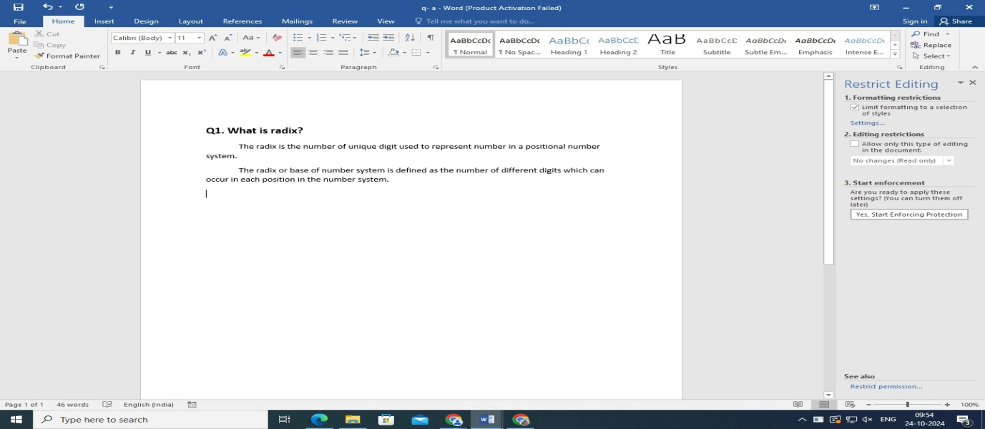

Encrypt with password and Restrict Editing

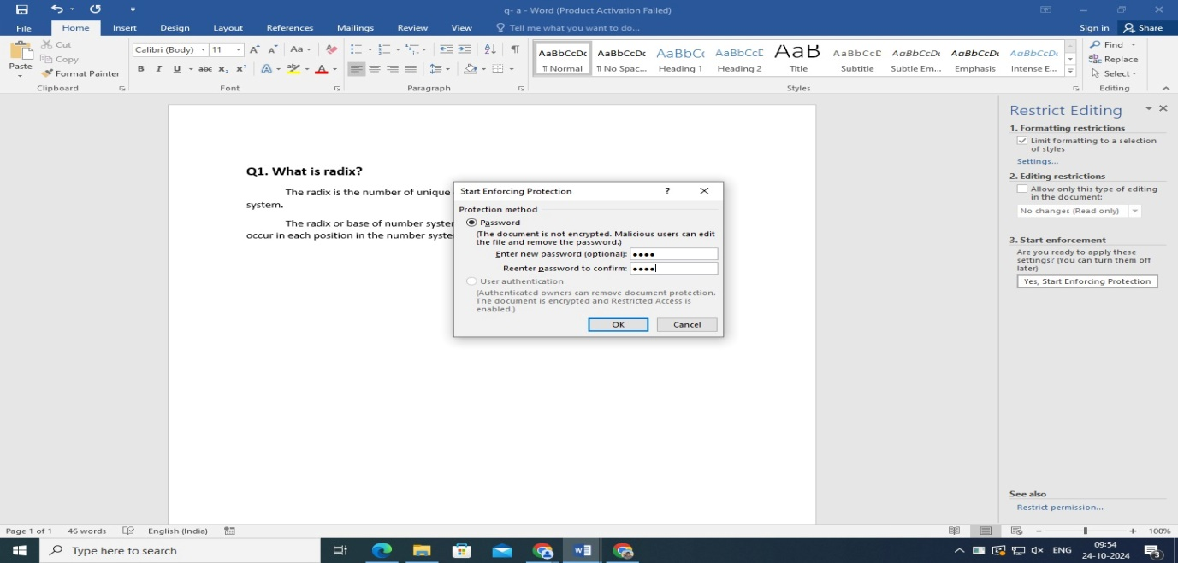

For editing enter password

No Editing here

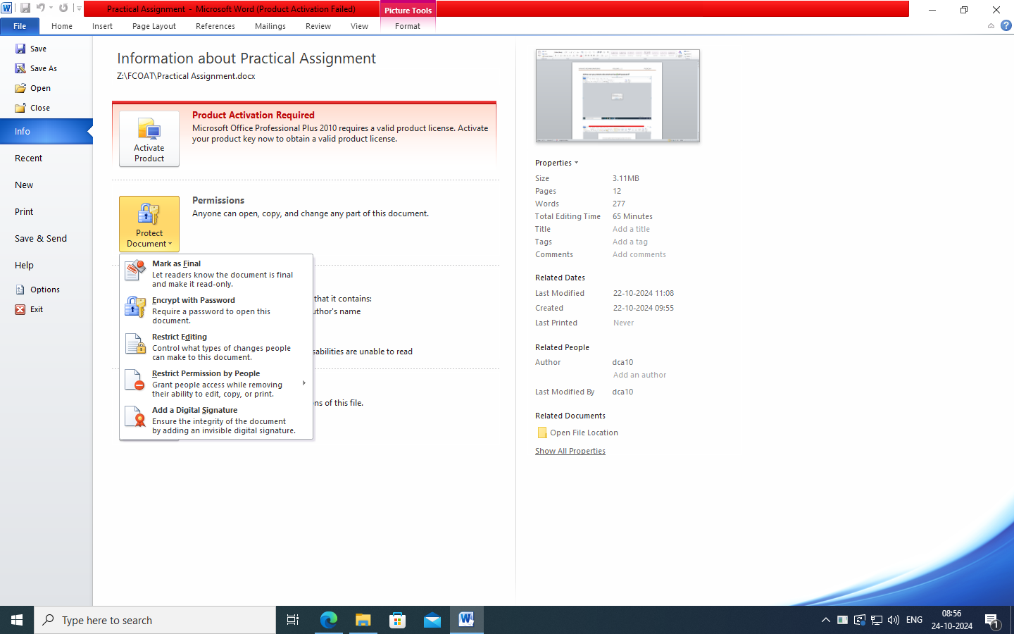**6) How can you protect a document and save with password?**

Encrypt with password

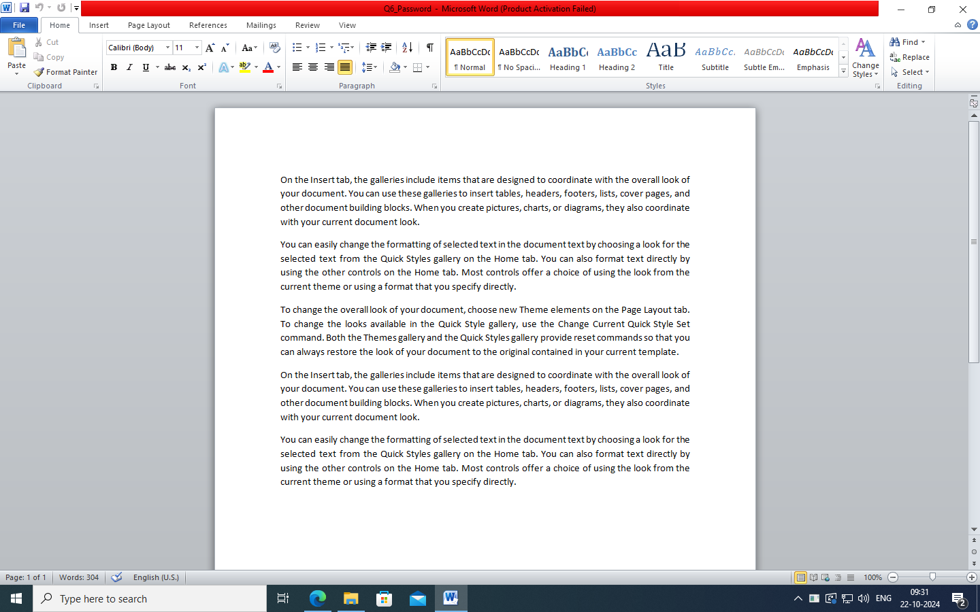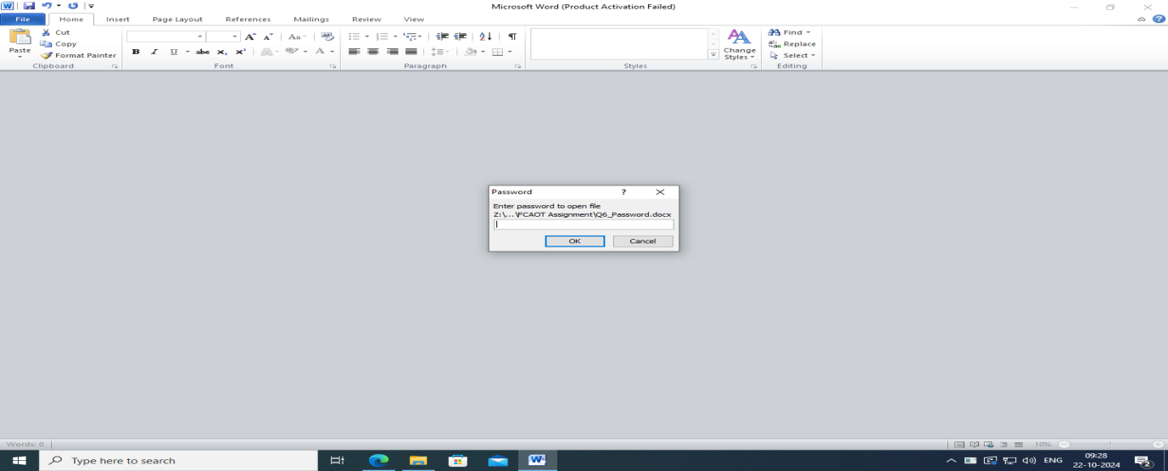

**7) How can you create and manage a custom bibliography with citations from different sources and styles, and ensure consistency throughout the document?**

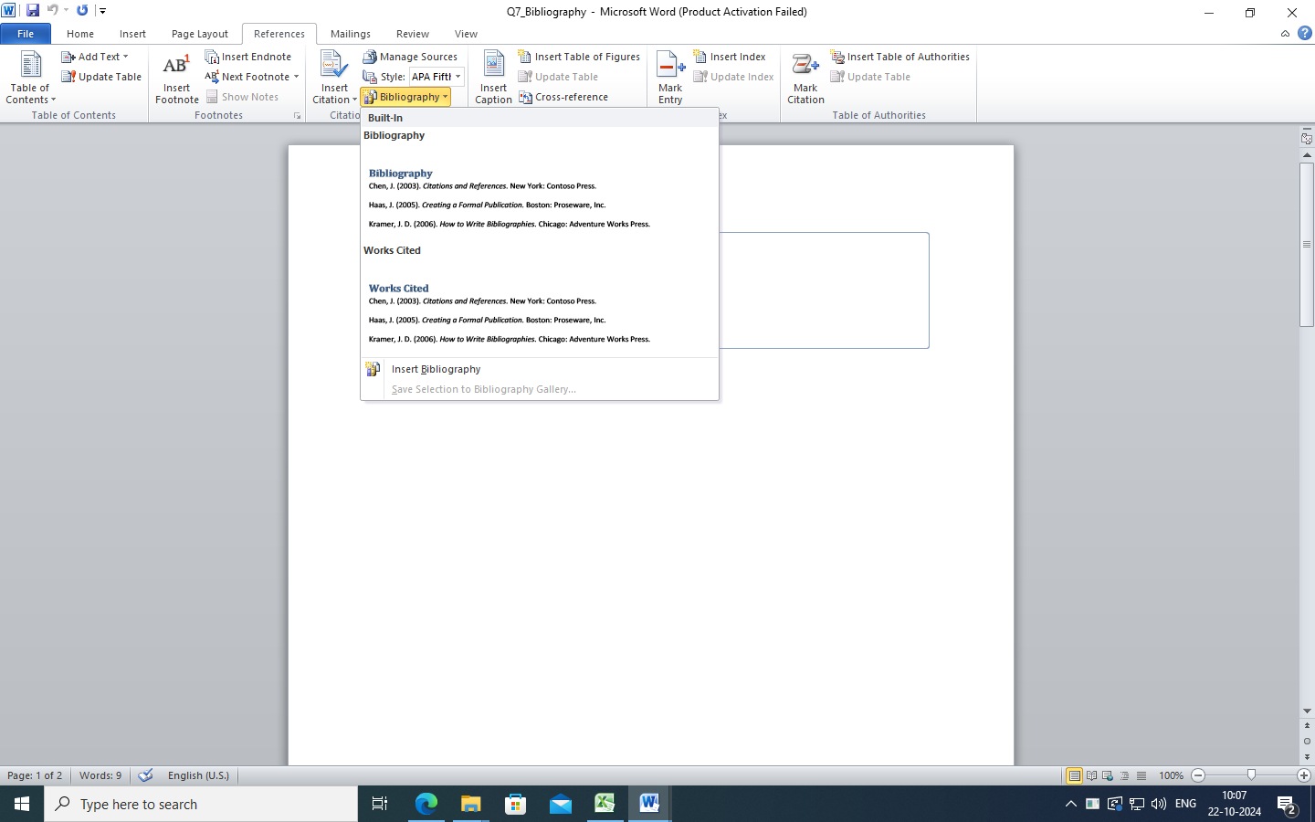

To add bibliography

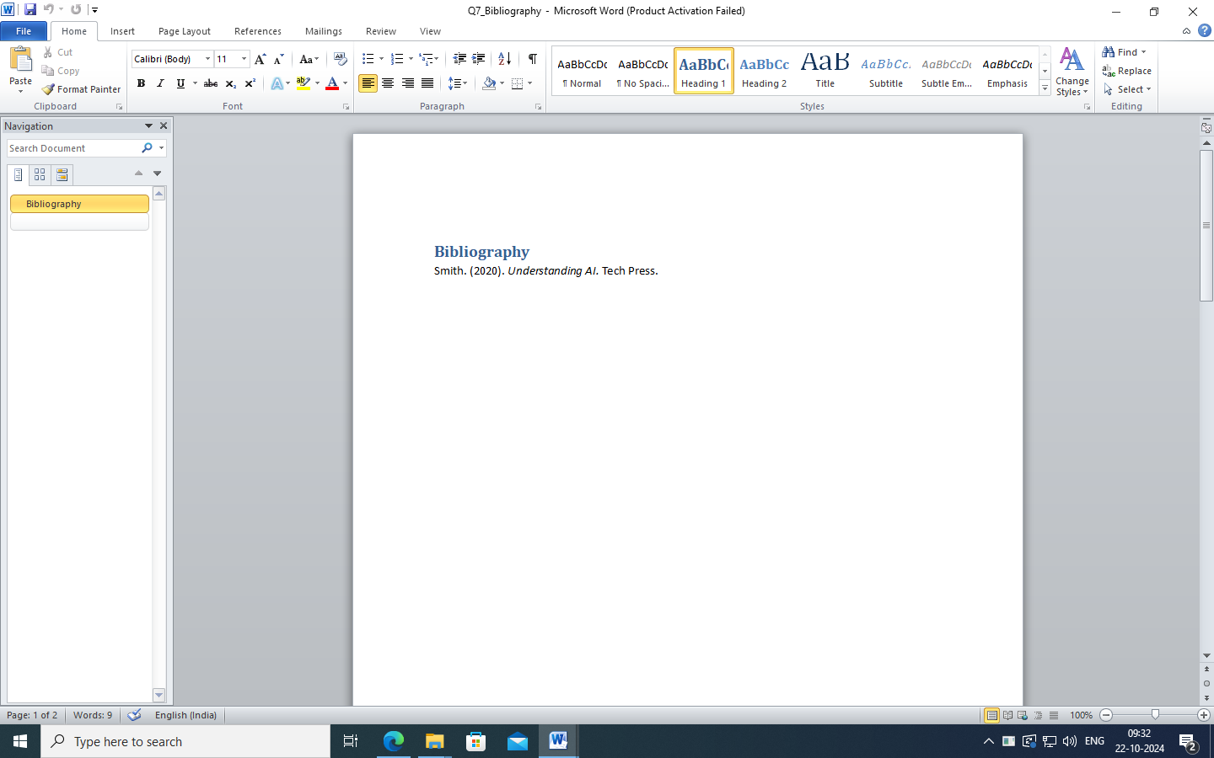

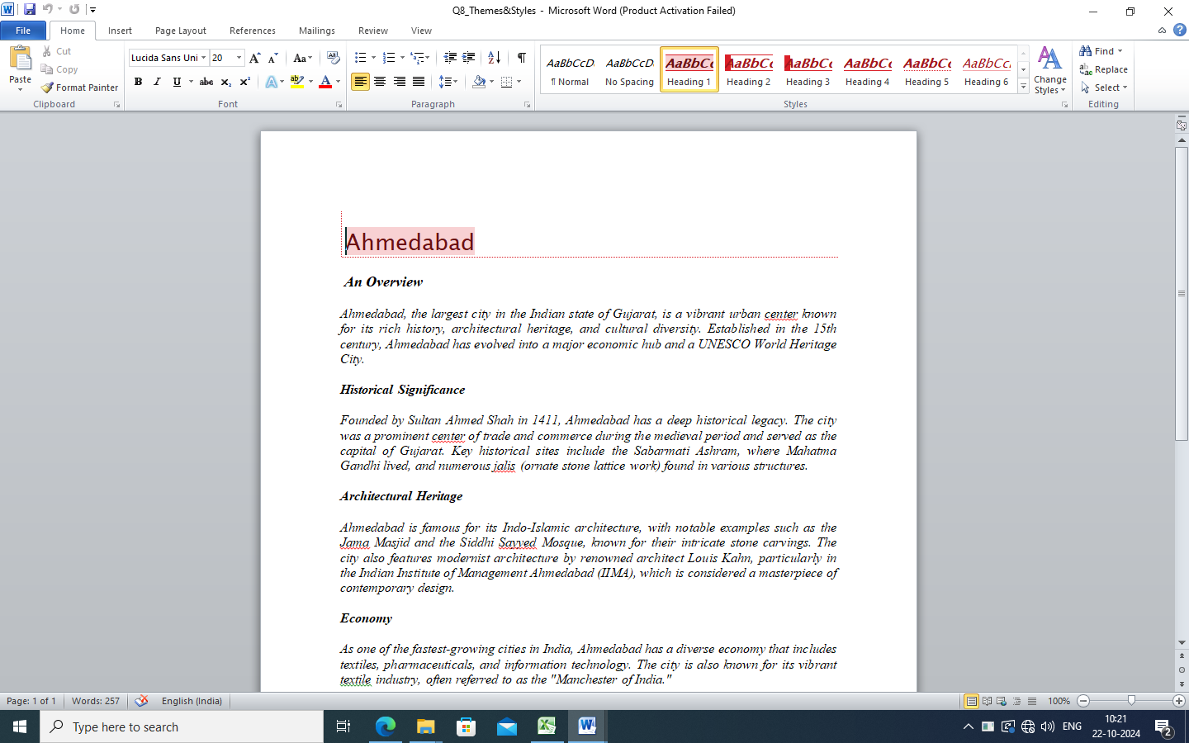**8) How do you apply advanced formatting to a document using themes and styles to ensure a consistent look across different sections?**

Use Styles

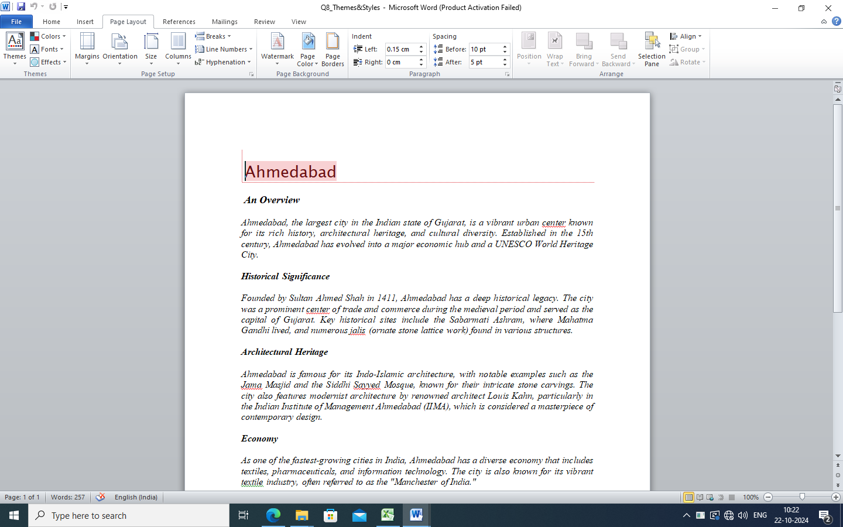

Use Themes

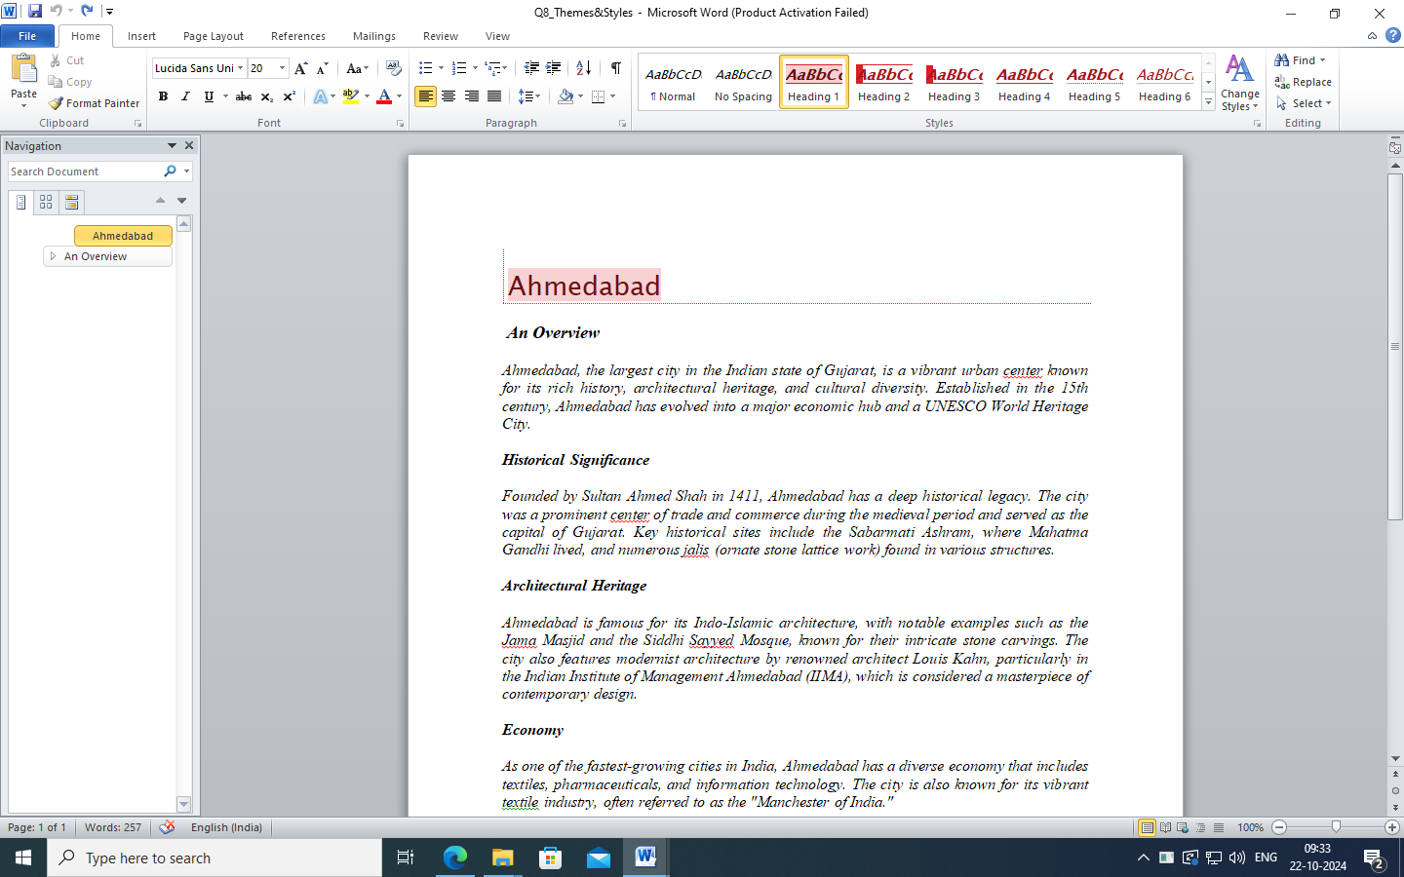

**9) How do you create a custom table (Train Time Table)**

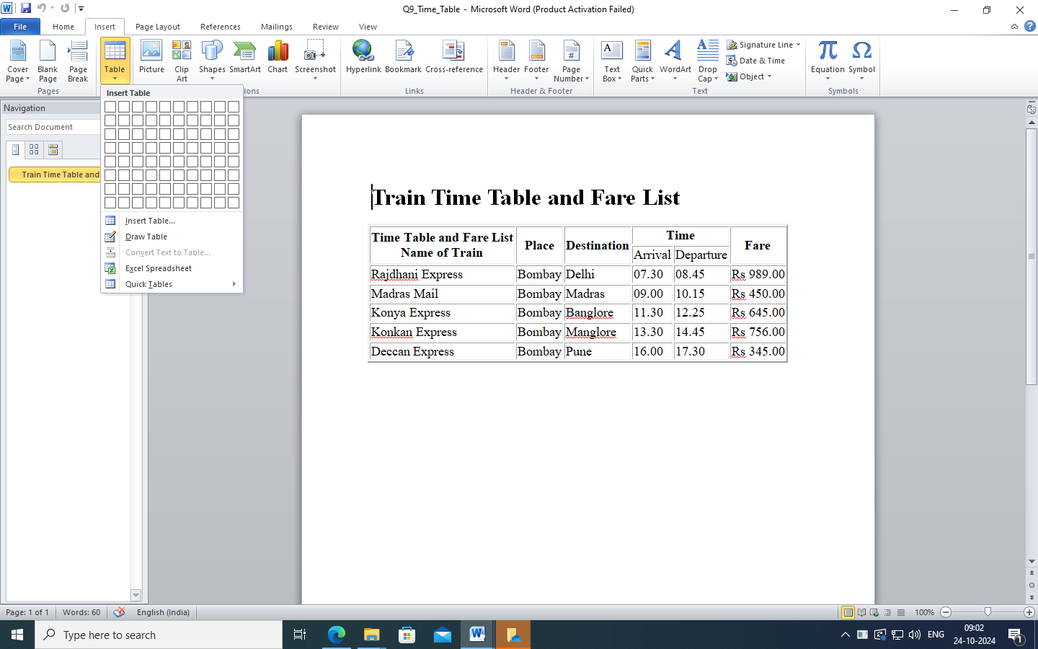

Insert table

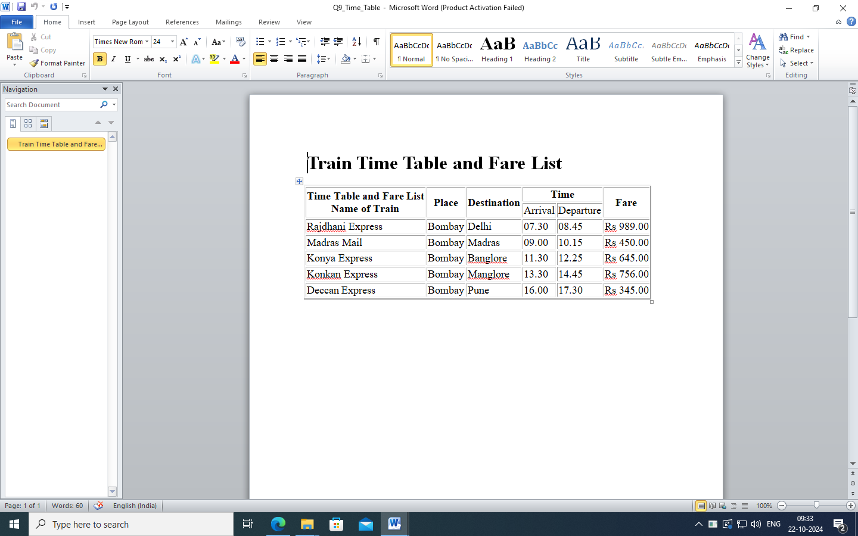

**10) How do you add and manage multiple citation sources in a document, including books, journal articles, and online resources, and ensure they are correctly formatted according to a chosen citation style?**

Use multiple citation

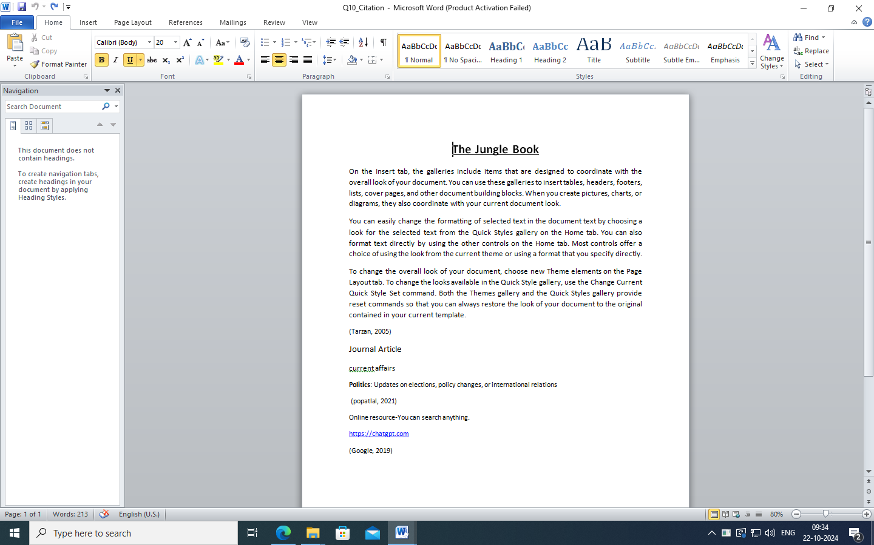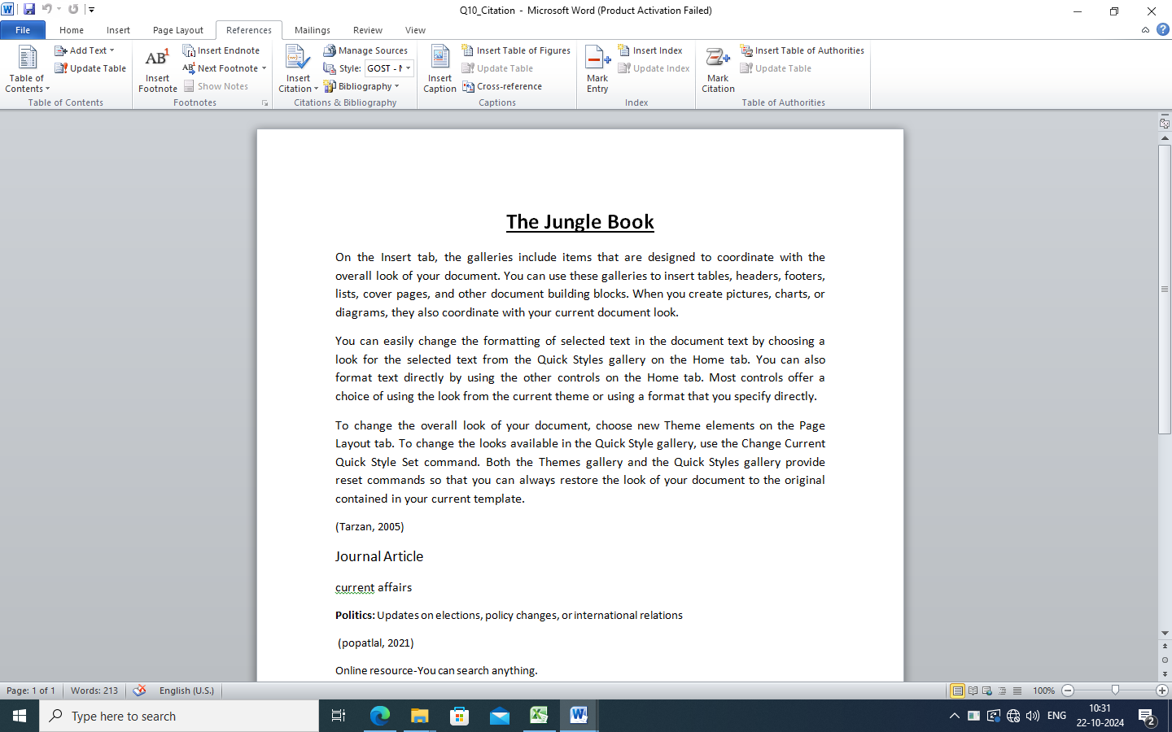

**11) How can you create and update a bibliography or works cited page in your document that automatically reflects all the sources you have cited?**

Use Multiply bibliography

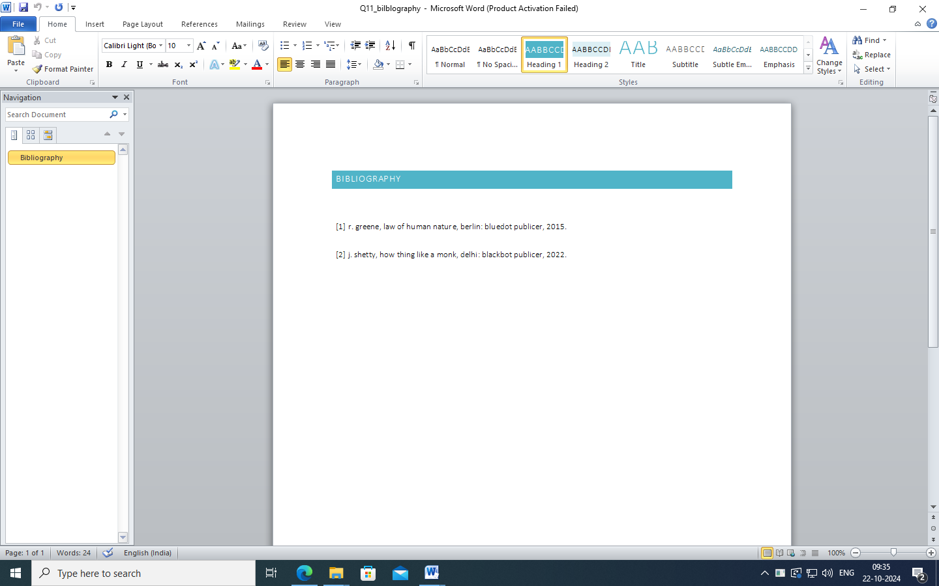

**12) How do you use the “Style” feature to apply consistent formatting to citations, footnotes, and endnotes, and ensure they match the rest of the document?**

Use footnotes, and endnotes

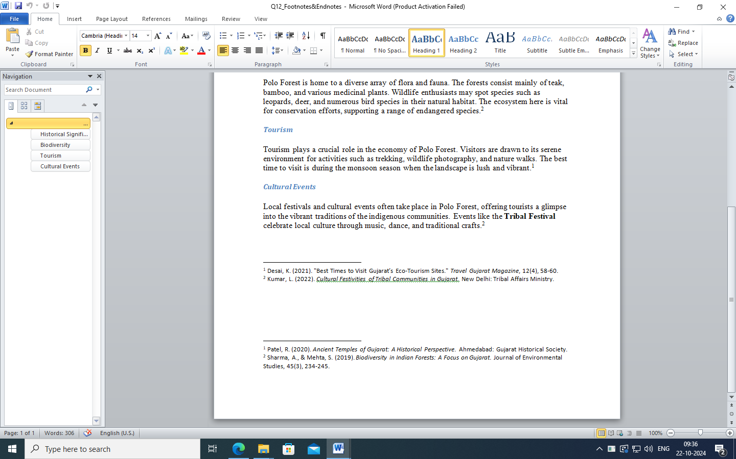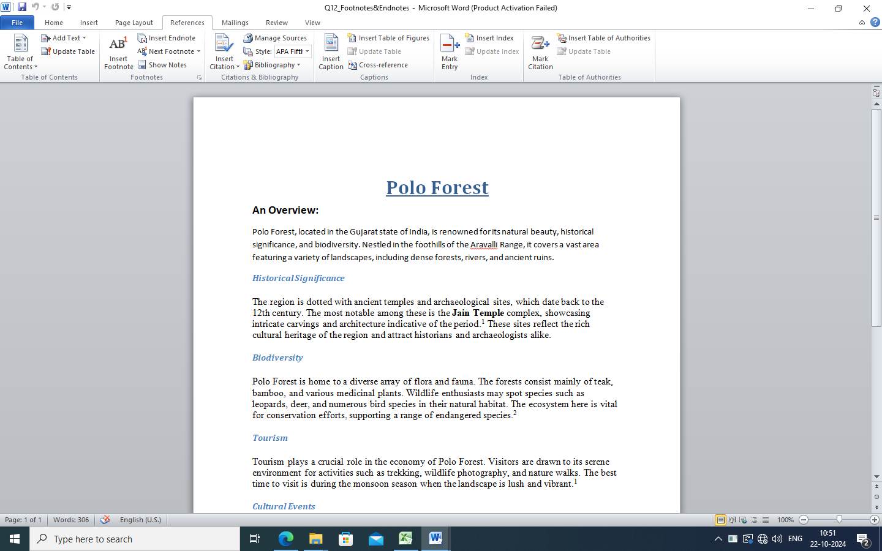

**13) How do you add comments to specific text or sections of a document, and ensure they are linked to the relevant text for easy reference?**

Add comments

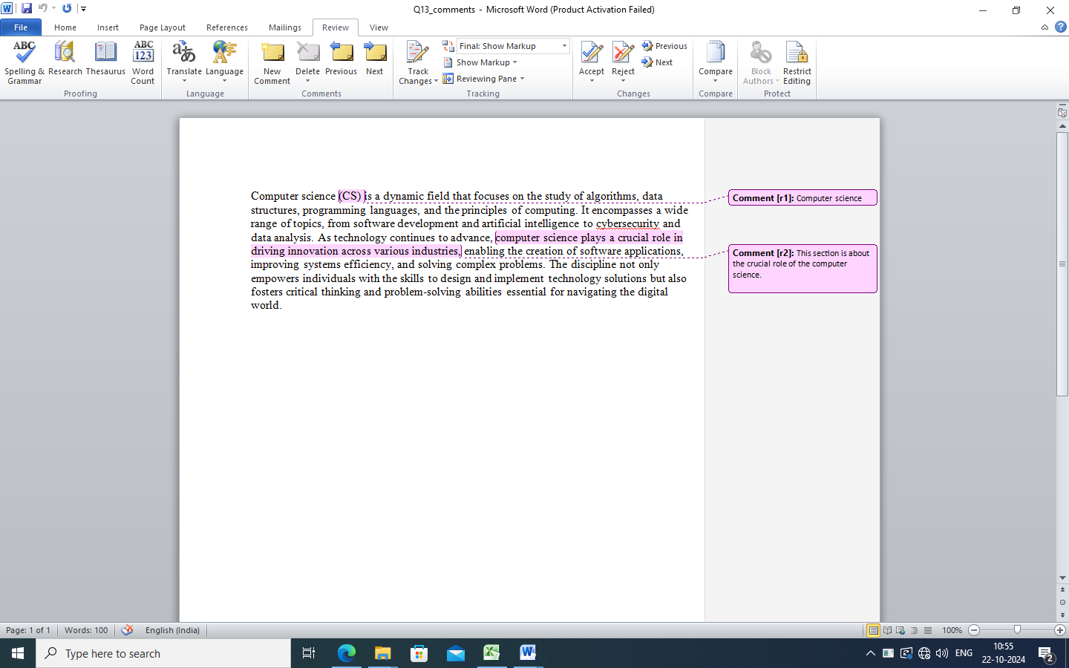

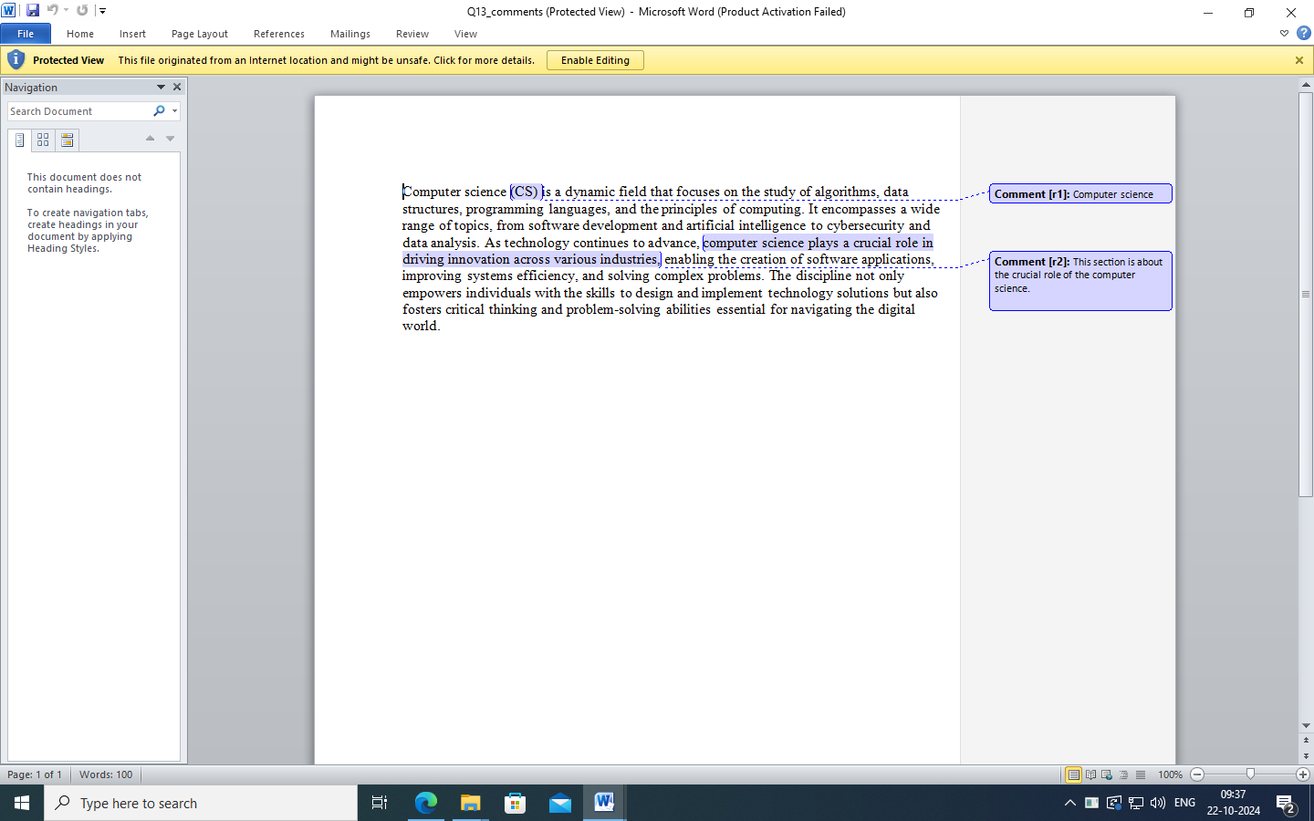

**14) How can you create a text as a hyperlink?**

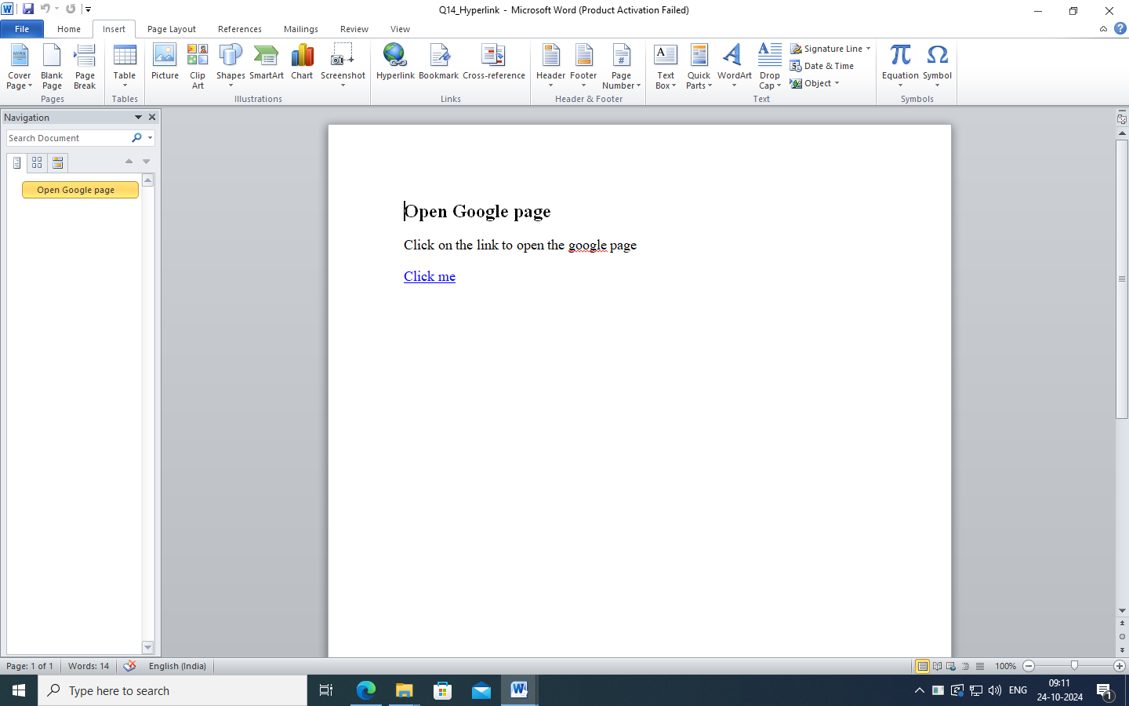

Use hyperlink

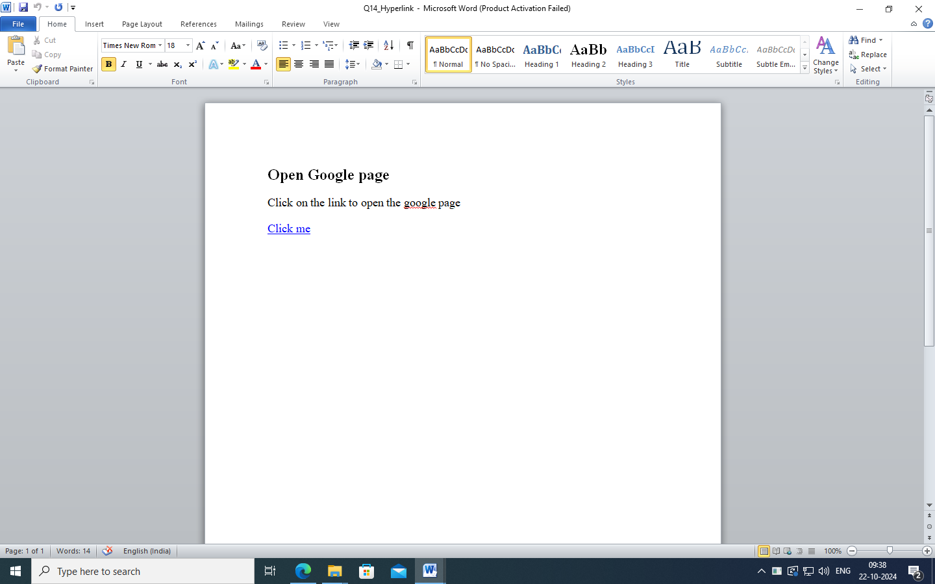

**15) How do you insert and format Clip Art in a document, including adjusting its size, position, and applying effects like shadows or reflections?**

Use Clip Art

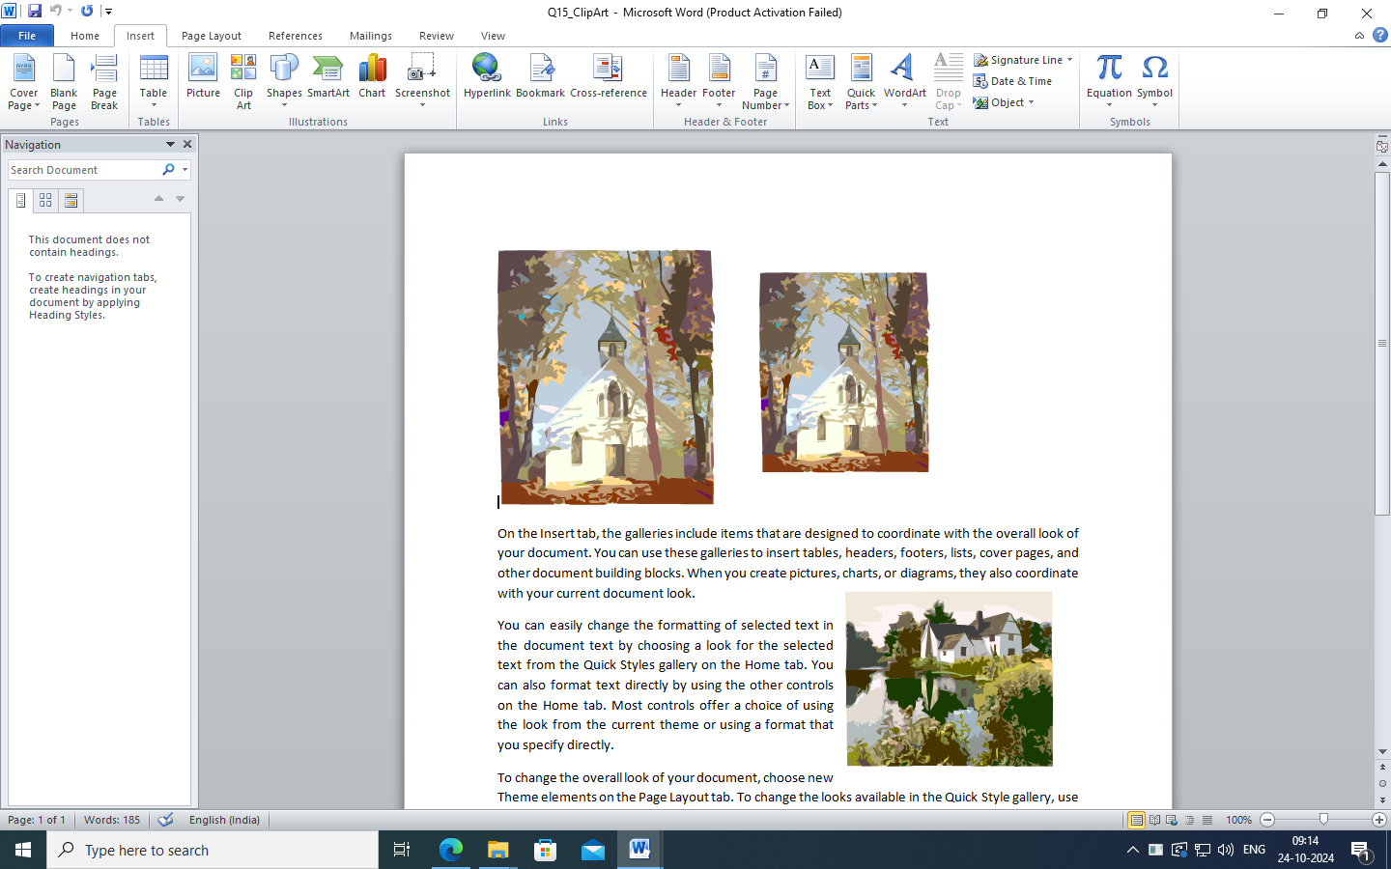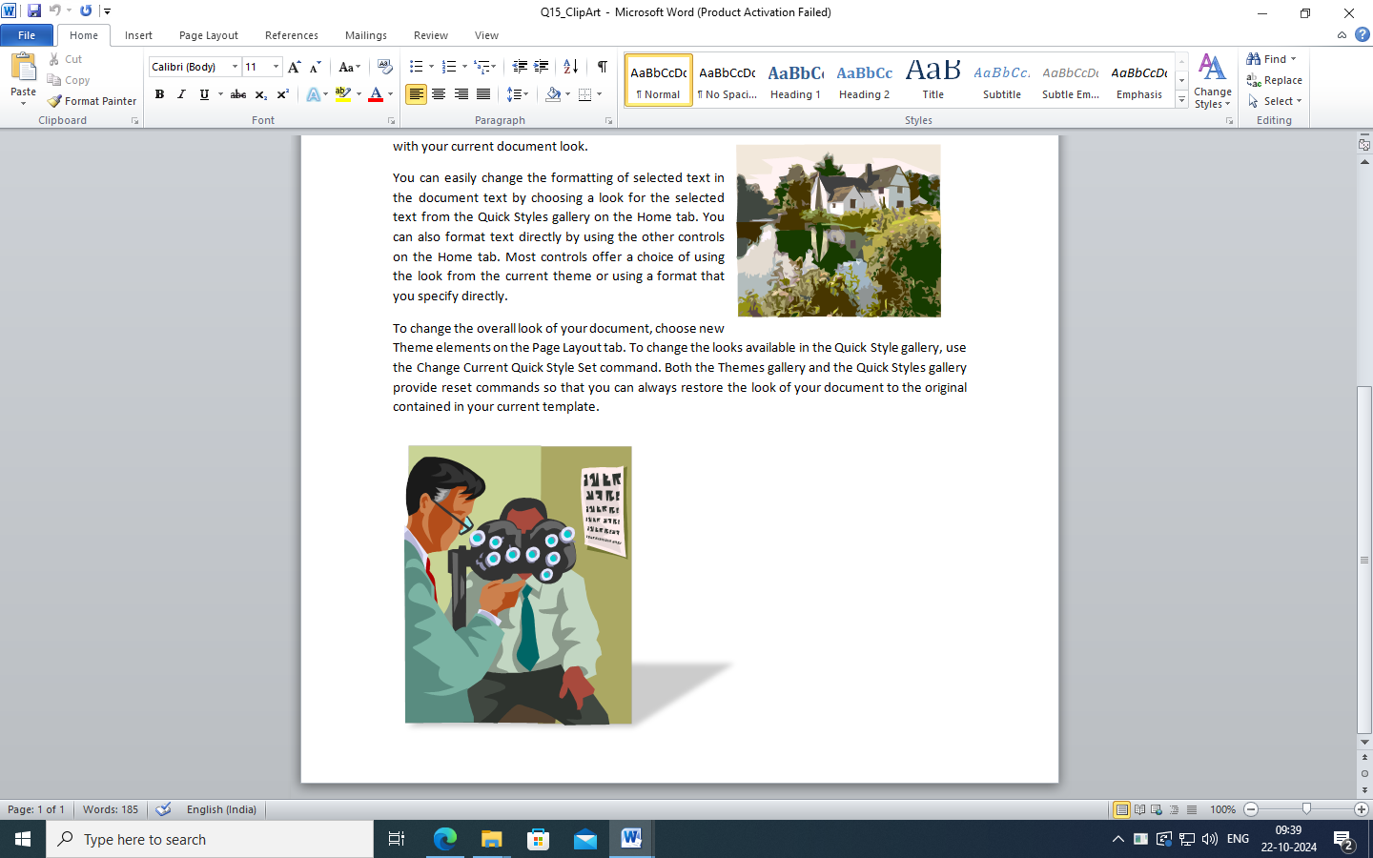

**16) How do you create and format custom Word Art, including choosing styles, colors, and effects to match the theme of your document?**

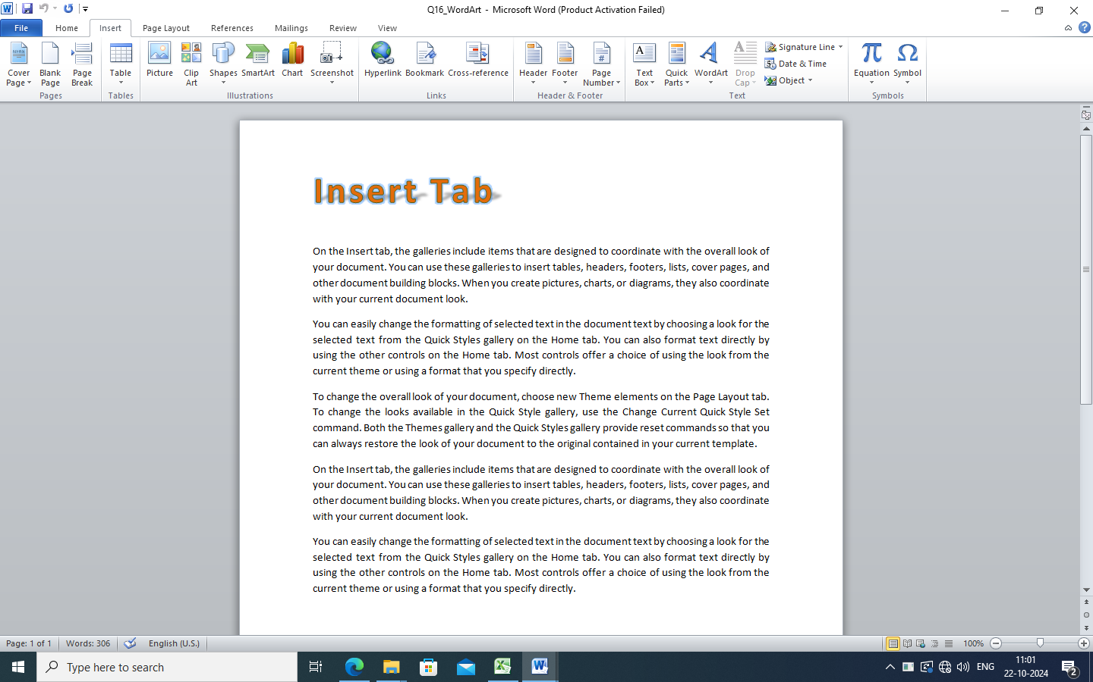

Use Word Art

Using Themes

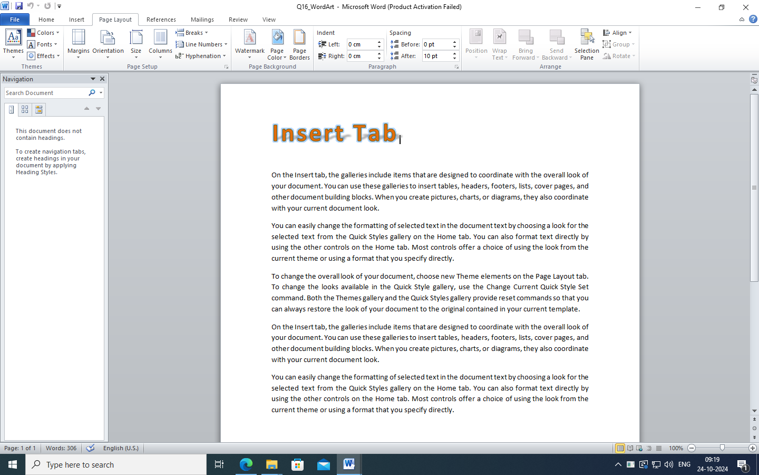

**17) How can you convert regular text into Word Art and apply advanced text effects such as 3D rotation or gradient fills?**

Use Word Art

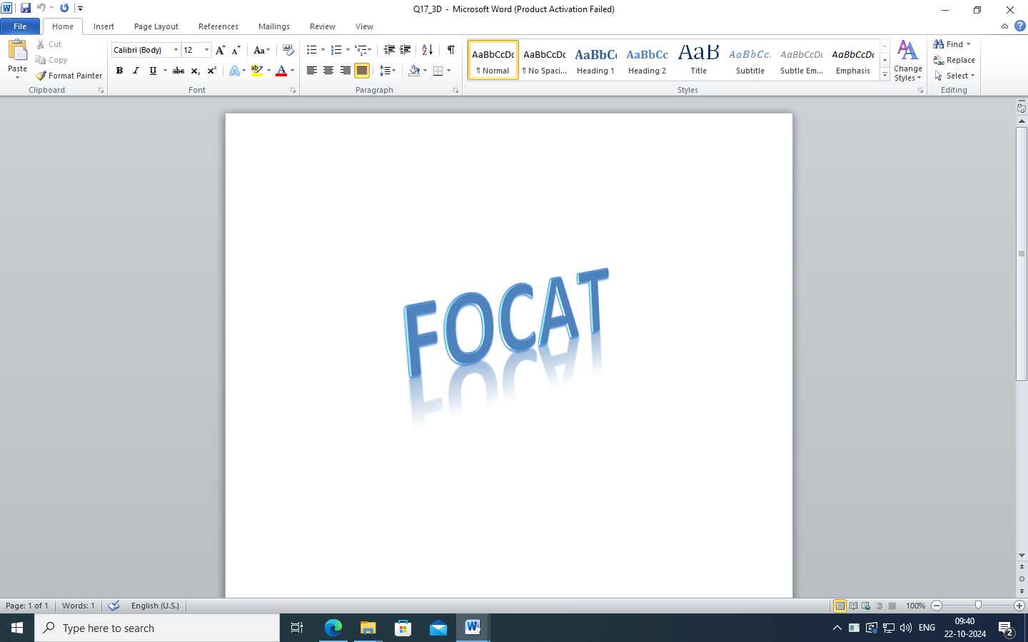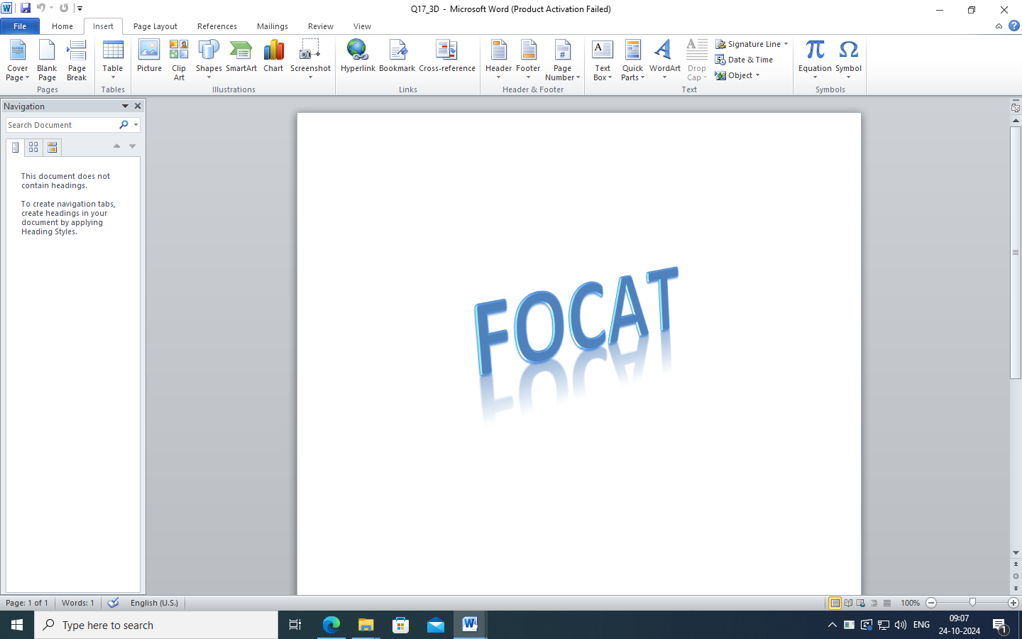

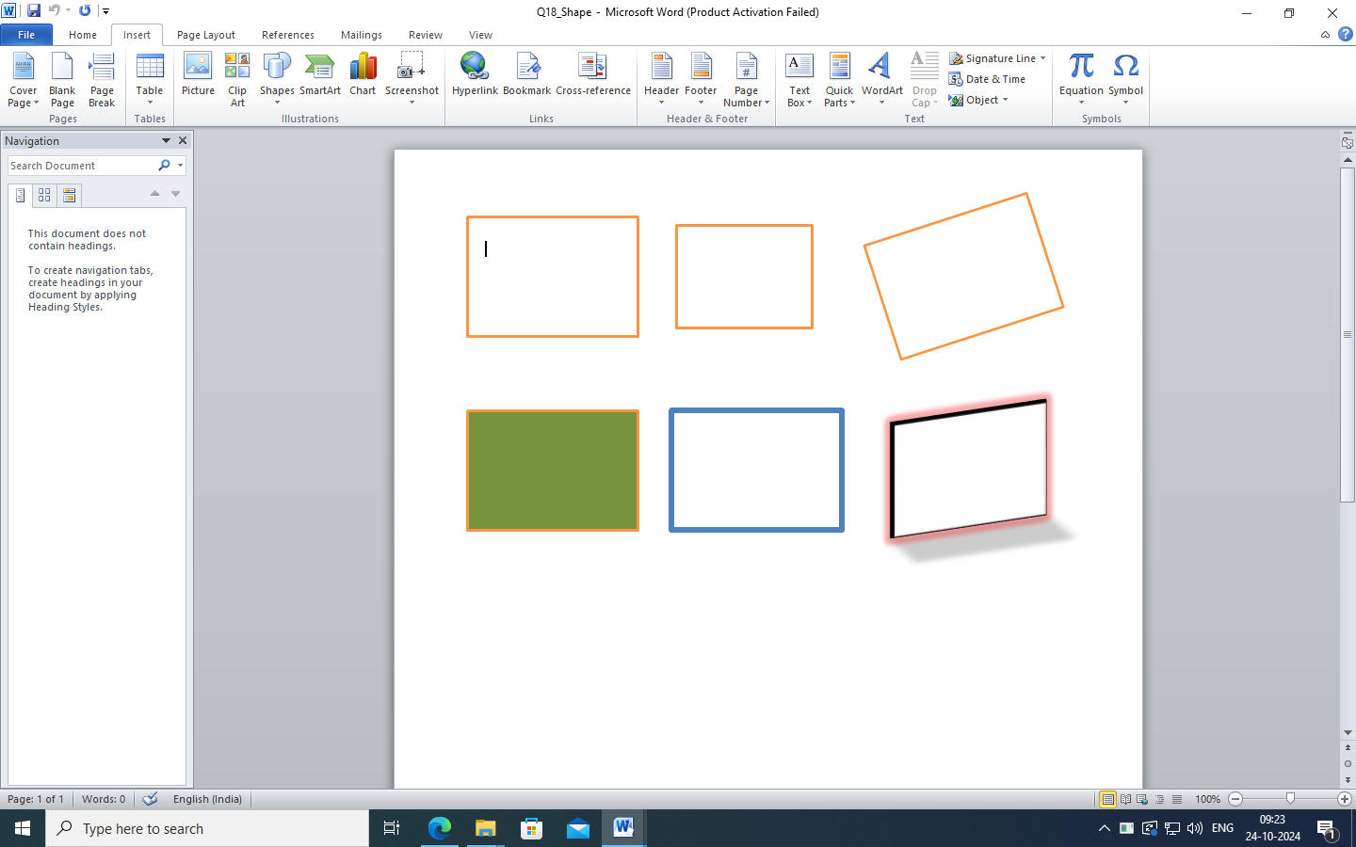**18) How do you insert and customize shapes in a document, including resizing, rotating, and applying formatting options like fills, outlines, and effects?**

Use Shape

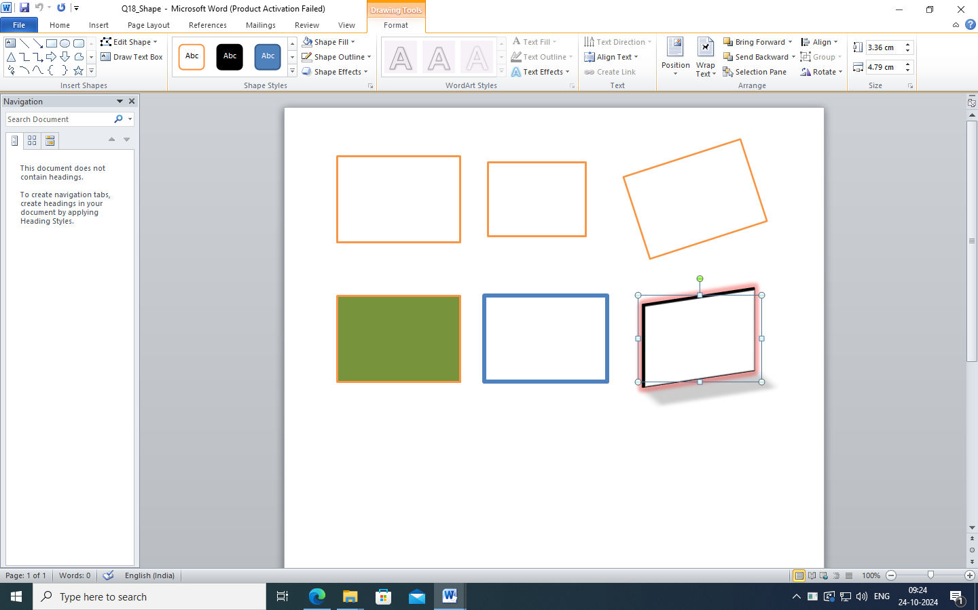

Use resizing, rotating,

Applying formatting options like fills, outlines, and effects

**19) How do you use SmartArt to create a hierarchical chart or process diagram, and customize it with different layouts, styles, and color?**

Using SmartArt, Chart

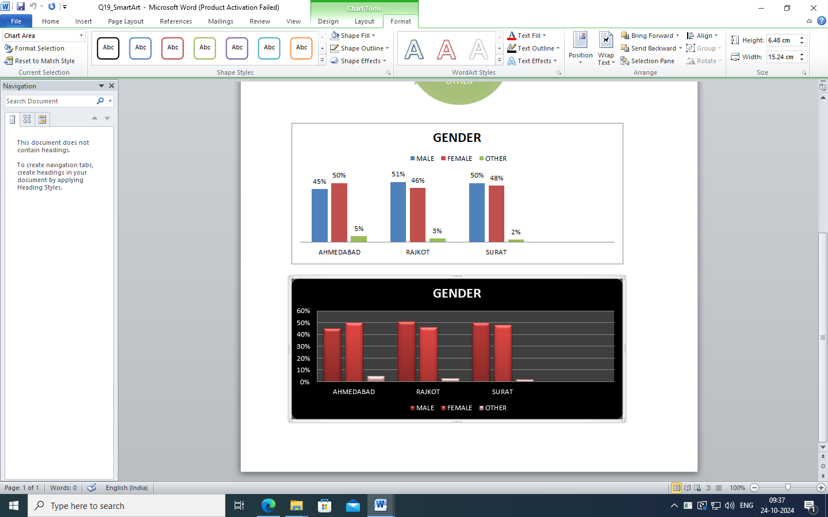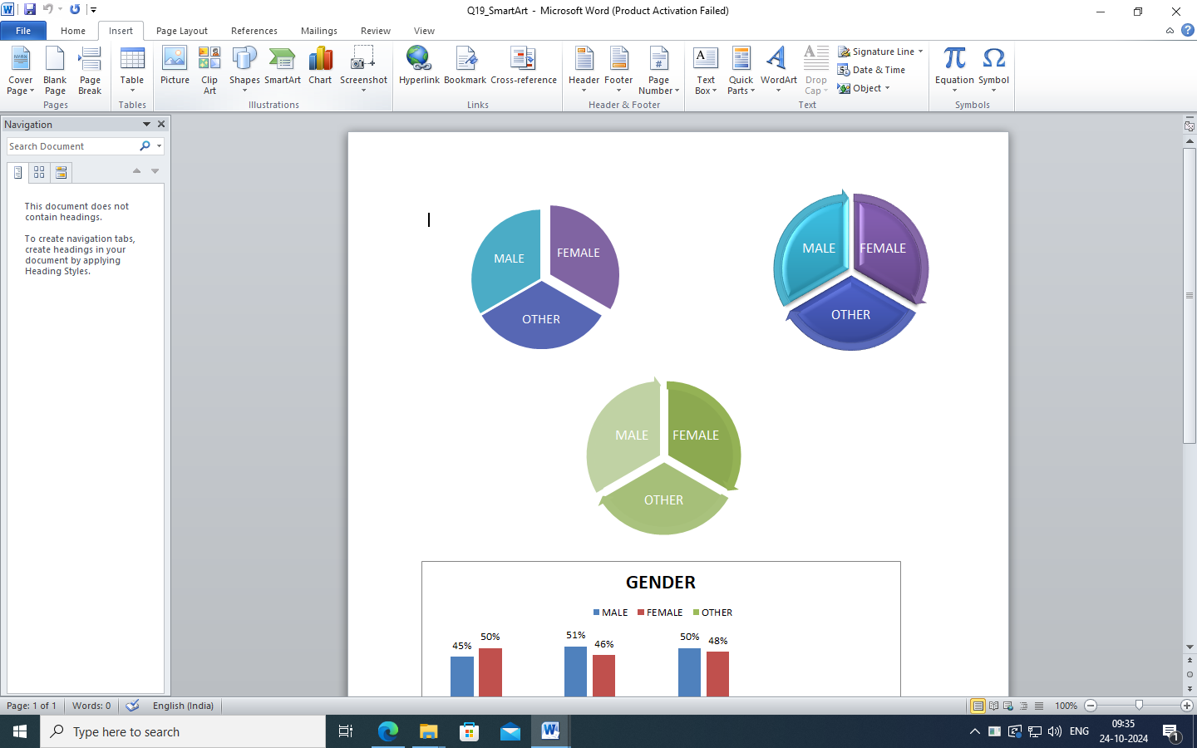

Use fill and change layout

Use Styles

**20) How can you add Date in Document.**

Add Date

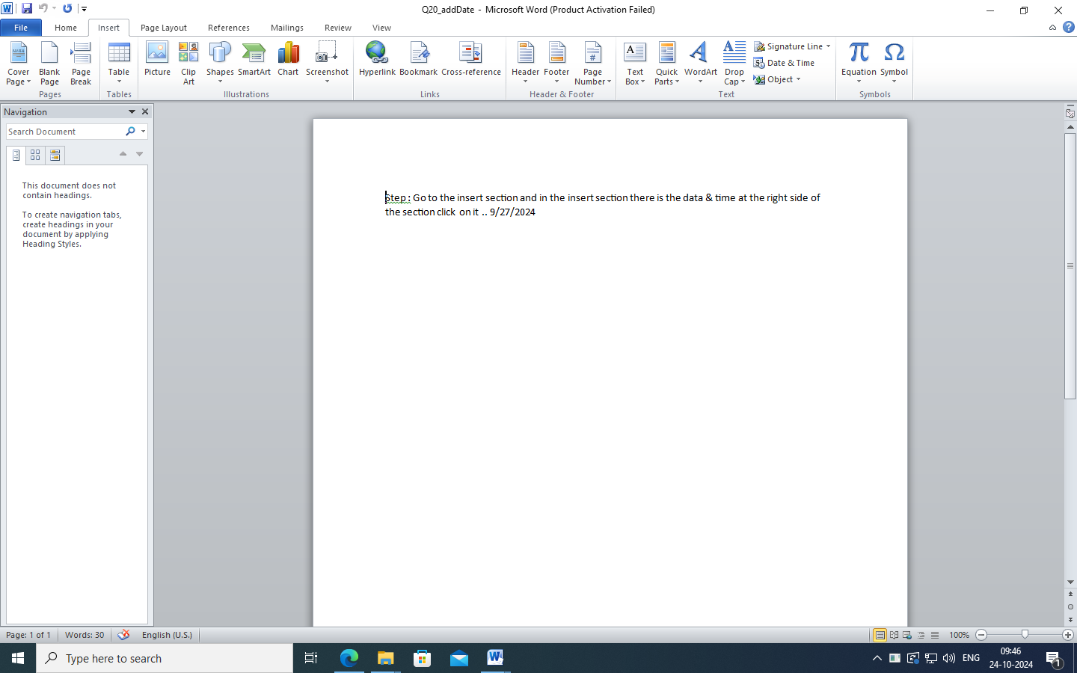

**21) How can you check track changes in document.**

Use track changes

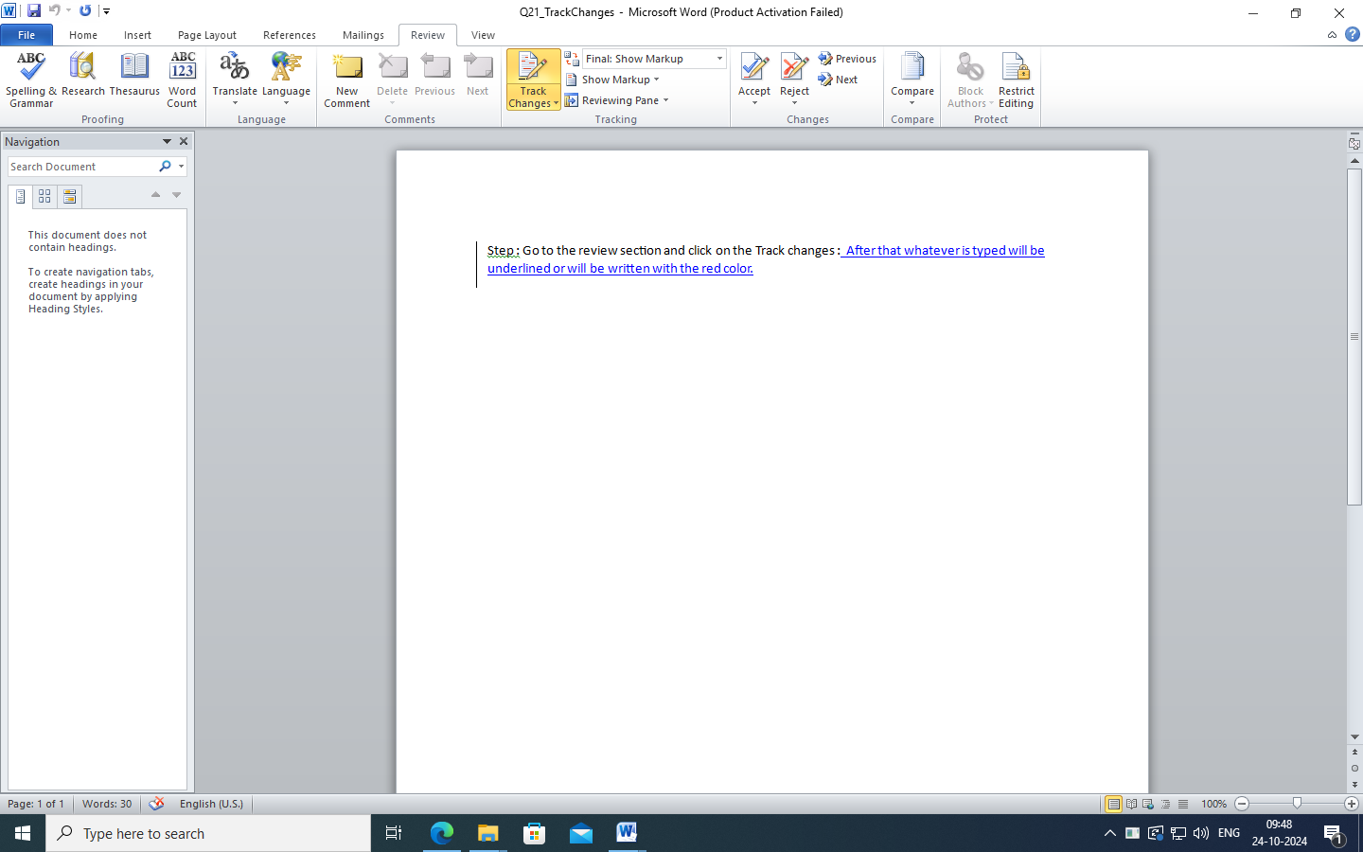

After enable track changes

